Name:_____________________ Class: 6.___ (Write A, B, or C)
Tell the story. For each picture write 3 sentences in past tense about what Fred or his family did.
Example:
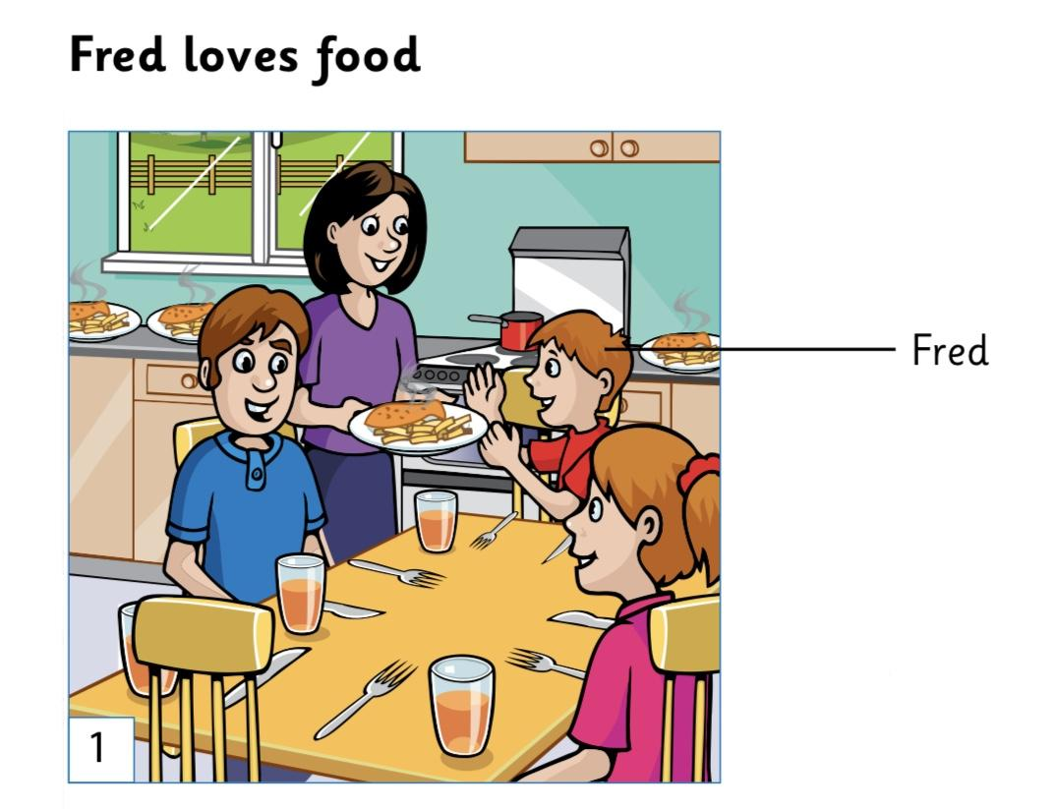
- Fred and his family sat down at the table to eat dinner.
- His mom made Fred’s favorite meal of fish and French fries.
- Fred’s mom carried the food to the table.
